# Project 4- Mergers and Acquisitions (M&A) Analysis Dashboard

## AIM

The Mergers and Acquisitions (M&A) Analysis dashboard aims to visualize the performance, trends, and key metrics of M&A activities over time. This includes the number and value of deals, sector-specific analysis, and regional insights. The dashboard supports data-driven decisions by providing a comprehensive overview of M&A activities.

## FEATURES

**Columns and Data Types Used**

1. **Years**: Year of the M&A activities
2. **Number**: Number of M&A activities per year
3. **Rank**: Rank of the deal based on value
4. **Date**: Date of the acquisition
5. **Acquiror**: Company that acquired another company
6. **Value in (bil. USD)**: Value of the deal in billion USD
7. **Number of Deals**: Number of deals in a specific sector or region
8. **Value (in bil. USD)**: Total value of deals in a specific sector or region

## METHODOLOGY

1. **Data Cleaning and Preparation**: Ensured the dataset was free from inconsistencies, duplicates, and missing values. Converted all necessary columns to appropriate data types for analysis.
2. **Visualization Creation**: Developed charts and graphs to represent the data clearly and effectively, focusing on key trends and metrics.
3. **Analysis**: Interpreted the visualizations to identify patterns, trends, and significant insights.

## OUTPUT

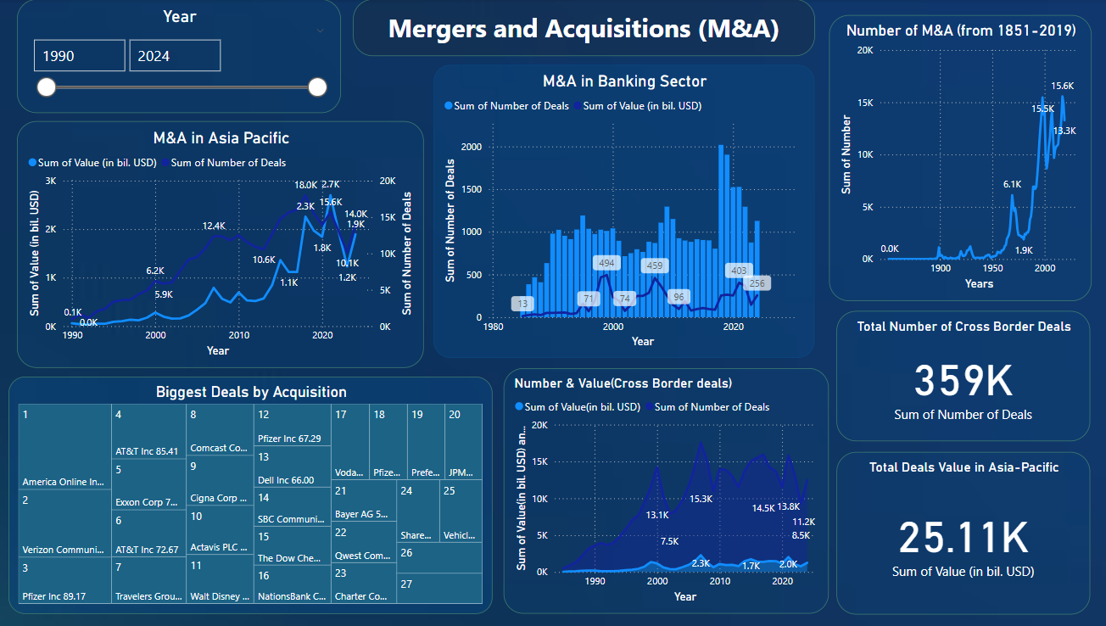

## RESULT ANALYSIS

**Explanation of Each Chart and Outcome**

1. **M&A in Asia Pacific**:
   * **Sum of Value (in bil. USD)** and **Sum of Number of Deals** are plotted over the years from 1990 to 2024.
   * The graph indicates a significant increase in both the number and value of deals over the years, with noticeable peaks in the early 2000s and mid-2010s, suggesting periods of heightened M&A activity in the Asia Pacific region.
2. **M&A in Banking Sector**:
   * This graph shows the **Sum of Number of Deals** and **Sum of Value (in bil. USD)** from 1980 to 2020.
   * The data highlights fluctuations in the number and value of deals over the years, with significant spikes around the early 2000s and late 2010s, indicating periods of intense M&A activity in the banking sector.
3. **Number of M&A (from 1851-2019)**:
   * The long-term trend of M&A activities, showing the cumulative number of deals over time.
   * There is a sharp increase in the number of deals starting from the mid-20th century, reflecting the growing prevalence of M&A activities.
4. **Biggest Deals by Acquisition**:
   * This table showcases the top 20 biggest deals by acquisition value, with notable transactions such as America Online Inc's acquisition for $164.75 billion and Verizon Communications Inc's $130.30 billion deal.
   * Highlights the major players and significant transactions that have shaped the M&A landscape.
5. **Number & Value (Cross Border deals)**:
   * Displays the number and value of cross-border deals over the years.
   * Indicates the increasing globalization of M&A activities, with a notable rise in cross-border deals, particularly in the late 1990s and early 2000s.

## SUMMARY OF ANALYSIS

The Mergers and Acquisitions (M&A) Analysis dashboard provides a comprehensive overview of M&A activities over an extended period. Key insights include:

* Significant growth in M&A activities in the Asia Pacific region, with peak periods indicating economic booms or strategic consolidations.
* The banking sector has seen fluctuating but generally increasing M&A activities, reflective of industry consolidation trends.
* Historical data shows a sharp increase in the number of M&A activities from the mid-20th century, aligning with global economic growth and market expansions.
* Major deals highlight key players and transformative transactions that have significantly impacted the market.